HHC-N-8I8O instructions
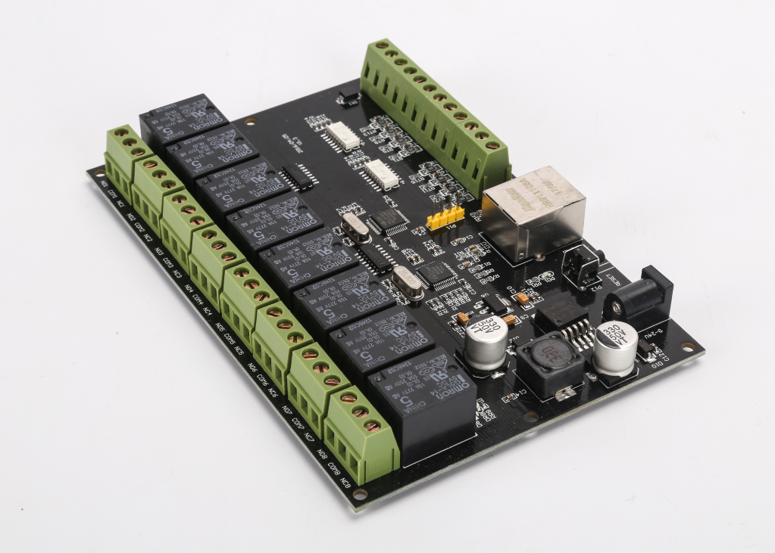
Product description
1. DC power supply 9-24V, power supply interface for DC head, head specifications 5.5-2.1MM (external diameter-internal diameter), if the use of 5.5-2.5MM power source may lead to poor contact. The power supply should not be less than 2A, less than 2A may cause the relay can not be absorbed. The DC block marked next to the 9-24V label is the current input interface.

2.8 relay output, output without voltage and current. Normally closed outputs are normally open. The output can be connected to 220V alternating current. The maximum output can be AC 10A and DC 5A. The maximum output power is 2KW. The maximum output voltage is 220V, and the maximum DC voltage is 30V. In actual use, there should be a margin, usually half. For example, the maximum load is only 1KW, and the AC current of the load current is not more than 5A.

3.8 switch input. Isolated optical lotus root input, passive or active input, passive input, P9 terminal, GND and COM with a short line connection (board has two COM terminals, just pick one of them), at this time, +5V and IN1 short connection means switching input. If it is an active input (input voltage 5V), COM should not be connected with GND. At this time, isolated input, input ground connection COM, positive connection IN1-IN8 can be. If you want to connect 12V input, IN1-8 should string a resistance of 1,000 Euros, otherwise the input circuit will be burned because of excessive current. The connection method of 12V input is different from that of 5V input. The ground wire of input is COM (COM and GND are not short connected), and the 12V signal of input is connected to IN1-8 after a resistance of 1,000 Euros.

4. The reset button P12 next to the power input is used to restore the factory settings. When the button is pressed and fixed, the product is energized (first the button is pressed and then the product is energized, and the line is plugged in). After 10 seconds, the button is released. Restore the factory settings, the factory set IP is 192.168.0.105, gateway is 192.168.0.1. Restore the device to power again.

5.devices can work in TCP server, TCP client and UDP mode.

Parameter configuration

Open the configuration software, select a good network card, click search. After searching for the device, the interface is as follows.
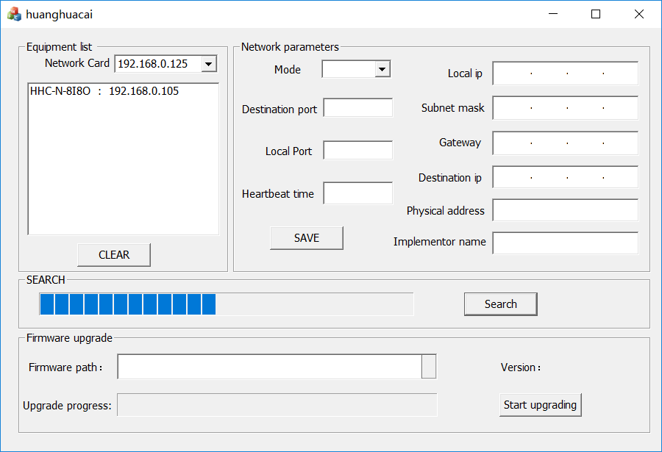

You can see that you can find a IP of 192.168.0.105 and double-click the IP to read the device parameters. To modify the parameters, we must double click to read it before modifying it.

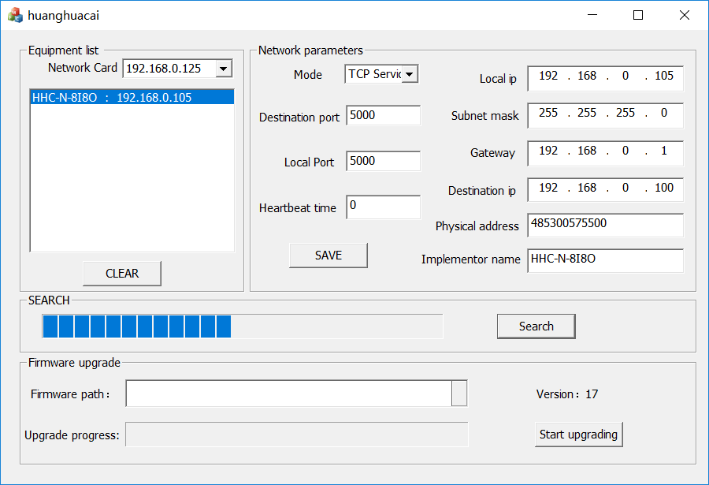
Modify the parameters to be set, click "Save Settings", if the device is normal, the device success dialog will pop up.
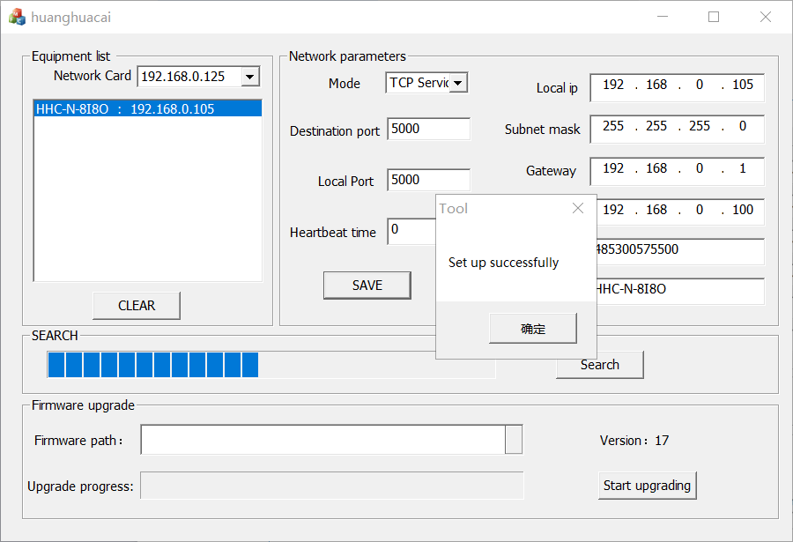

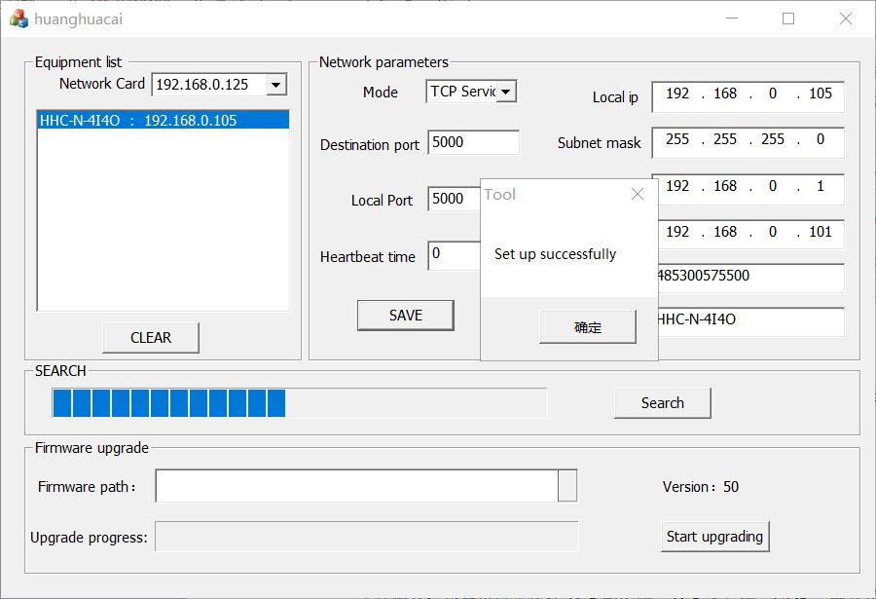

Configuration description.
Working mode: devices can work in three ways: TCP server, TCP client and UDP.

1. TCP server mode

In this mode, the device must use TCP client mode to connect to the device. In this mode, the work supports the connection of 4 TCP clients. For example, set the device port number to 5000, it supports 5000, 5001, 5002, 5003 these four ports of network connection.

2.TCP client

The device works in this mode, and it automatically connects to the connection of the TCP server. The remote IP and remote port in the configuration page are the parameters of the TCP server.

2.UDP

Devices working in this mode, it can only work with the same device in UDP mode, configuration page remote IP and remote port is the parameters of UDP connection.

Heart beat time: This is the time to calculate the data of the network port, in 10 seconds, the default is 12, which means that if the network port does not receive valid commands after 120 seconds, it will restart the network. If the device is connected with TCP, it will break the network. Set it to 0 and turn off this function. This function can be used for network detection. By default, if it is turned on, a valid command such as read is sent to the device to keep the connection in circulation during heartbeat time.

Device Name: It can be defined in Chinese and English, which can easily manage various devices without recording cumbersome IP.

MAC Address: The default MAC unification is 485300575500. If multiple devices are used, it is necessary to modify the MAC address. 48 does not need to be changed, other locations are changed at will, and the local area network is different.

Firmware upgrade:

Search for the device to be updated, then double-click the device to be searched, read the parameters, select the firmware to upgrade in the firmware path, and then click "Start Upgrading", about 10 seconds, start upgrading firmware, after the upgrade is completed, there are prompts.

When upgrading, the gateway of the equipment should be in the same network segment as the computer, otherwise the upgrade fails. After the upgrade fails, the factory settings should be restored (the reset button next to the power input is the reset button, which is used to restore the factory settings. When the button is pressed, the product is energized and the button is released after 10 seconds), and the IP of the computer should be set manually. 192.168.0.1 segment. Once the upgrade is successful, the device will be able to work properly after the upgrade is successful. No need to upgrade without changing functions.

Command description:
Commands are sent in character.
Control one relay
Open the first relay.
Send: on1
Return: on1
Turn off the first relay.
Send: off1
Return: off1
The 2-8 way control is the same as the above instructions.

Read relay status
Send: read
Return: relay 00000001 (state of 8-way relay, 1 relay suction, 0 relay unlock, 1 relay suction, 2-8 relay unlock)

Control all relays
Send: all00000011
Return: relay00000011

All is the control of all relay instructions, the latter 8 control, 1 means suction, 0 means loosening the above instruction means the first way suction with the second way, 3-8 way loosening. This instruction returns to the state of the relay after execution. The state return information of the relay is the same as that of the read instruction.

Delay control
For example, if the relay is to be pulled in after 2 seconds, the following instructions can be issued.

Send: on1:02
Return: on1

In the above instructions, the relay will be released after 2 seconds, on1: the relay to be controlled, followed by a delay time of up to 99 seconds, for example on2:12 means that the second relay will be released after 12 seconds. The other 2-8 way control is the same as above.

Read switch input

Send: input
Return: input00000001
Input followed by 00000001, 1 means switching input, 0 means no switching input, 8-way switching input state, the above instructions indicate that the first way has switching input, 2-8 channels have no switching input.

Test instructions.
The device works on the TCP server.
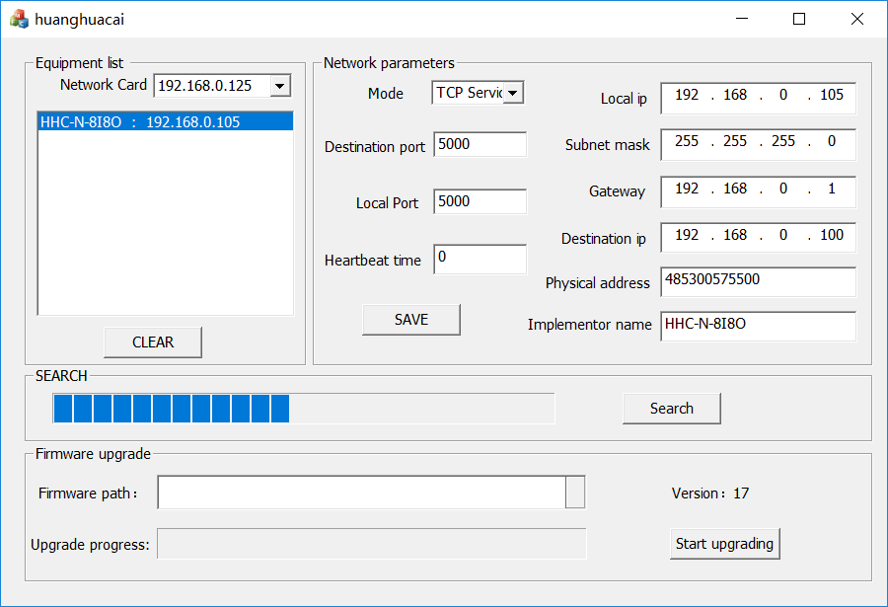
Open application software.
Click the connection button, if the connection is successful, if shown in the following figure.
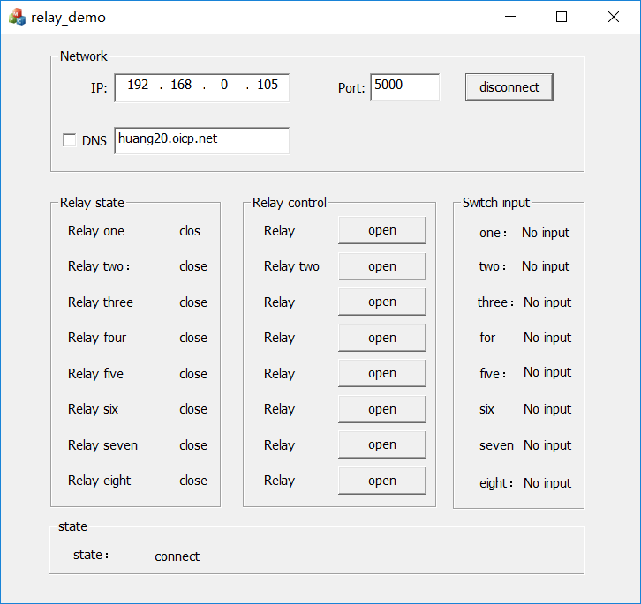
Wiring instructions
